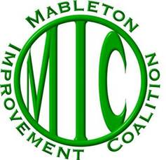

Mableton Improvement Coalition (MIC) is a non-partisan, all-volunteer organization made up residents who are dedicated to a better quality of life in Mableton. We are not the government and have no power to decide zoning cases, enact laws or enforce any laws. MIC can only advocate for its positions or decisions – in the exact same way as any other citizen could. MIC was not involved in any group or organization that advocated for or against cityhood. None of our sitting Board of Directors and Officers are running for office in the new city of Mableton. Board members or officers who intend to run for office in the future must resign from the Board of Directors.

Despite recent accusations to the contrary, the Mableton Improvement Coalition (MIC) has scrupulously maintained a neutral stance on the Mableton cityhood question. For all its 20-year history MIC has steadfastly maintained a non-partisan, neutral position in political matters. Nowhere have we published or spoken to a position of approval or opposition to the establishment of the City of Mableton. With the passage of the cityhood referendum in November 2022, it is MIC’s position that residents should come together to support the new City regardless of their position prior to the November election. MIC is committed to having a productive relationship with our new Mayor and Council, just as we enjoy with Cobb County officials.

During the campaign on the cityhood question, MIC hosted both pro and con perspectives in our Facebook Mableton Community group. To be clear, MIC and the Austell Community Task Force presented the only community forum that included both proponents and opponents of cityhood. Questions about the pro-cityhood movement or the anti-cityhood movement should be directed to those organizations or individuals that supported or opposed cityhood.
MIC advocates for the entire Mableton community, carries out projects that benefit the community, and keeps our members informed. Information on the outstanding work our volunteers do in the community can be found on our website at: www.mableton.org/what-mic-does/. Anyone interested in volunteering to be a part of this exceptional community work should contact us at info@mableton.org.
Board of Directors
Mableton Improvement Coalition

